

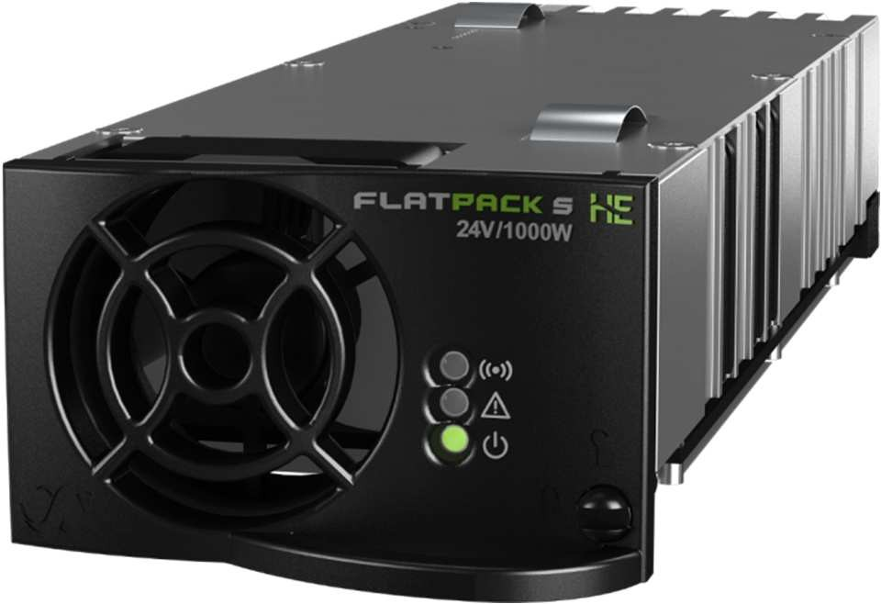
Compact HE rectifier for rail and power utilities applications

Applications in these markets demand state of the art, reliable and safe DC power systems. Flatpack S delivers an industry leading power density in its segment, many safety functions, wide operating temperature range and superb reliability in its small 217mm deep housing.

Used in the 3U rack with Smartpack S controller, the Flatpack S rectifiers cover 2 to 8kW applications using a minimum of space, less than 18 liters, and low heat dissipation.

APPLICATIONS
Flatpack S 24V Rectifier
24/1000 HE
Doc 241122.205.DS3 – v5
RAILWAY & METRO
- Control and protection

POWER UTILITIES
- Control and monitoring systems.
- Alarm systems
- PLC systems

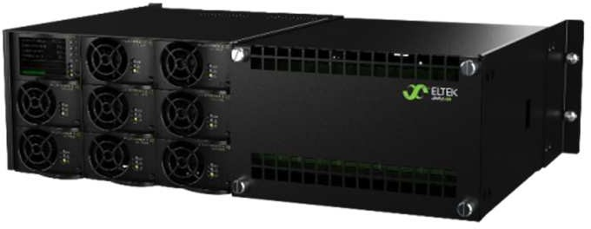
KEY FEATURES
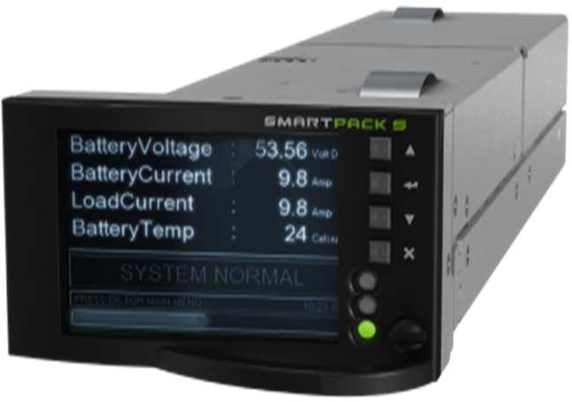3U 8kW system
- SMALL
- SHORT
- POWER DENSE, 26 W / CU IN
- HIGH EFFICIENCY
- ORING PROTECTION ON OUTPUT
- HOT PLUG-ABLE
- VOLTAGE KEYING

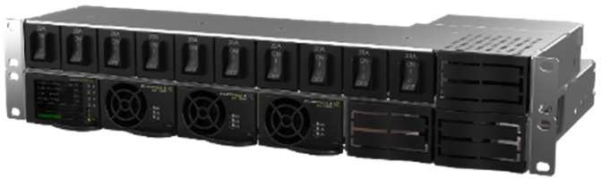
1U 3kW bulk feed power shelf and 2 pole dist

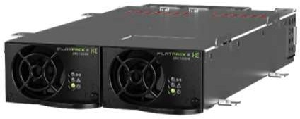

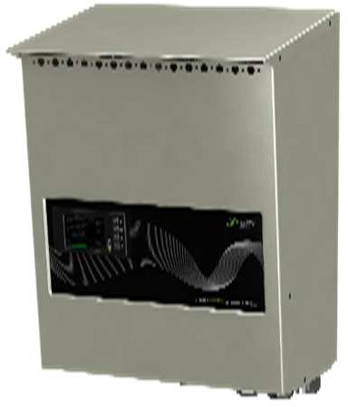2kW wall box (MFGS0208.001)
2pos standalone power shelf (PN: 241122.903)
Smartpack S controller

Flatpack S 24V Rectifier 
Doc 241122.205.DS3 – v5

Model | 24/1000 HE
Part number | 241122.205
INPUT DATA
Voltage (nominal range) | 185 V_{AC/DC} - 305 V_{AC} / 300V_{DC}
Voltage (operating range) | 85 V_{AC/DC} - 305 V_{AC} / 300V_{DC}
Frequency (nominal / range) | 45 - 66 Hz / DC
Maximum current | 5.9 A_{RMS}
Power Factor | > 0.99 at 50% load or more
Protection | Fuse  Shutdown above 305 V_{AC} / 300 V_{DC}
OUTPUT DATA
Voltage (default) | 26.7 V_{DC}
Voltage (adjustable range) | 21 - 29 V_{DC}
Max power, nominal input | 1000 W
Max power, @ 85 V_{AC/DC} | 440 W
Max current | 41.7 A (@V_{OUT} < 24 V_{DC})
Current sharing | ±5% of maximum current from 10 to 100% load
Static voltage regulation (10-100% load) | ±0.5%
Dynamic voltage regulation | ±5.0% for 10-90% or 90-10% load variation, regulation time < 50ms
Hold up time | >20ms; output voltage > 21 V_{DC}
Ripple | < 150 mV_{PP} , 30 MHz bandwidth
Protection | Blocking OR-ing Diode, Short circuit proof, Over voltage protection and High temperature protection
OTHER SPECIFICATIONS
Peak Efficiency | 92.5 %
Isolation | 3.0 kV_{AC} - input and output, 1.5 kV_{AC} - input earth, 0.5 kV_{DC} - output earth
Alarms (Red LED) | Low mains shutdown, High and low temperature shutdown, Rectifier Failure, Overvoltage shutdown on output, Fan failure, Low voltage alarm, CAN bus failure
Warnings (Yellow LED) | Rectifier in power de-rate mode, Remote battery current limit activated, Input voltage out of range, flashing at overvoltage
Normal (Green LED) | Input and output ok
Potential alarm relay (normally closed) | Opens on alarms and mains outage
MTBF (Telcordia SR-232 Iss.3 Meth. II Case L1) | >1 975 044 (@ T_{ambient} : 25 °C)
Operating temperature (5 - 95% RH non-cond.) | - 40 - 85°C [-40 - 185°F ]
Max output power de-rates above temp / to | 45°C [+113°F] / 400 W
Storage temperature | -40 to +85°C (-40 to +185°F), humidity 0 - 99% RH non-condensing
Dimensions[WxHxD] / Weight | 72 x 41.5 x 217mm (2.83 x 1.63 x 8.54”) / < 850 g (1.9 lbs)
DESIGN STANDARDS
Electrical safety | EN 60950-1:2006+A11:2009+A1:2010+A12:2011+A2:2013 IEC 60950-1:2013, UL 60950-1:2014
EMC | EN 61000-6-1:2007, -6-2:2005, -6-3:2007 + A1:2011, -6-4:2007 + A1:2011, TS  61000-6-5, EN 300 386:v1.6.1, FCC CFR 47 Part 15:2013
Marine | DNVGL-CG-03391), ABS PDA Certificate1)
Environment | ETSI EN 300 019: 2-1 (Class 1.2) & 2-2 (Class 2.3) EU 2015/863 (RoHS) & 2012/19/EU (WEEE)  Normal operating conditions as per IEC 62040-5-3:2016 clause 4.2. Other operating conditions as per IEC 62040-5-3:2016 clause 4.3, must be advised
1) only valid for part number 241122.205M
Specifications are subject to change without notice

